**Game Concepts Report**

**Team Members**

Kyle Gibson – Banner ID B00366928

**Game Overview**

I’m going to create a game that represents a Metroid-vania style (such as Hollow knight) which would allow the player explore caverns and dungeons, defeating enemies, etc. Main target audience is mainly for the hardcore, retro players but it depends since many players love new and old games.

Mainly many influences of Metroid and Castlevania style games, hence the term “Metroid-vania” like Hollow Knight, Dead Cells, Axiom Verge, Cave Story, etc.

The player must explore a cave to find a certain item to complete the game, which is simple, but many enemies would stop their way.

**Core Objective**

Player needs to collect the item at the end of the dungeon, then must get back to the beginning, this will/might repeat and gets more difficult and enemies would increase.

There will be extras, easter egg areas, which will increase the score in a certain way.





End

Item

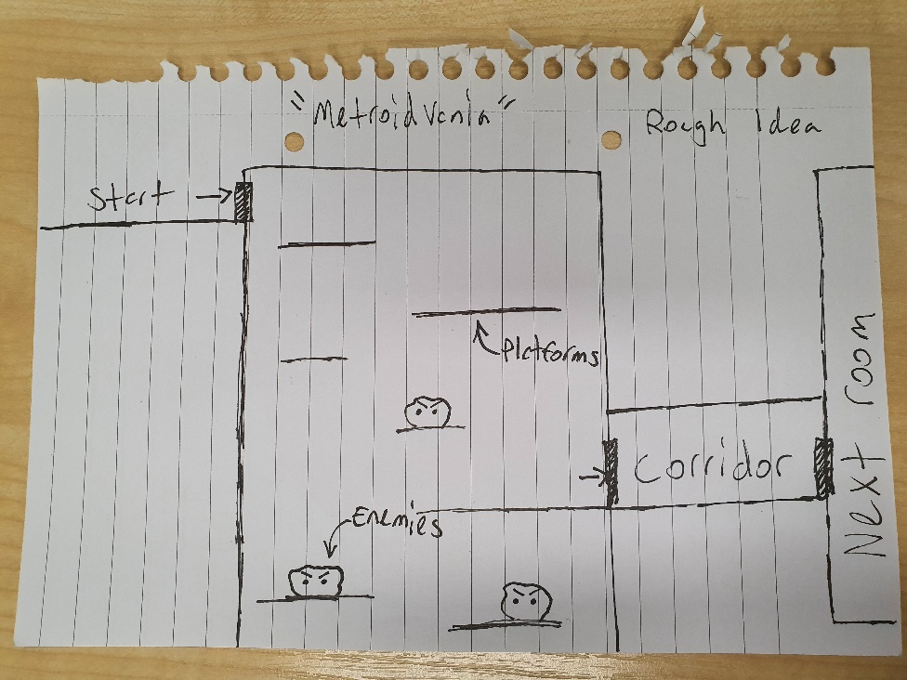

Rough Sketch